**Task #1**

From task 1 I learned some of the cool features eclipse carries. Eclipse is great IDE that provides an easy installation process of plugins via Eclipse Marketplace. Plugins are components that provided by eclipse to help you build applications via connecting with other plugins to form running applications. Coming from NetBeans background, I thought this was pretty nifty. Per instruction on task 1, we were asked to install JAutodoc and practice using on a simple “HelloWorld” application. The result is as followed:

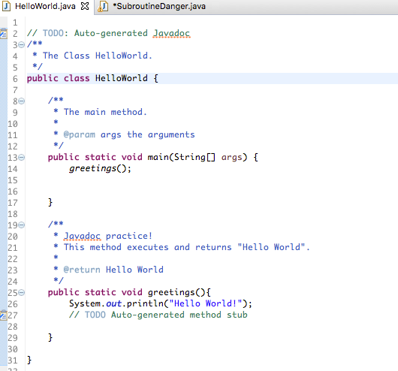

This tutorial taught me how to generate comment for method using JAutodoc in eclipse. I can see how this will save a lot of time during developing.

**Task #3**

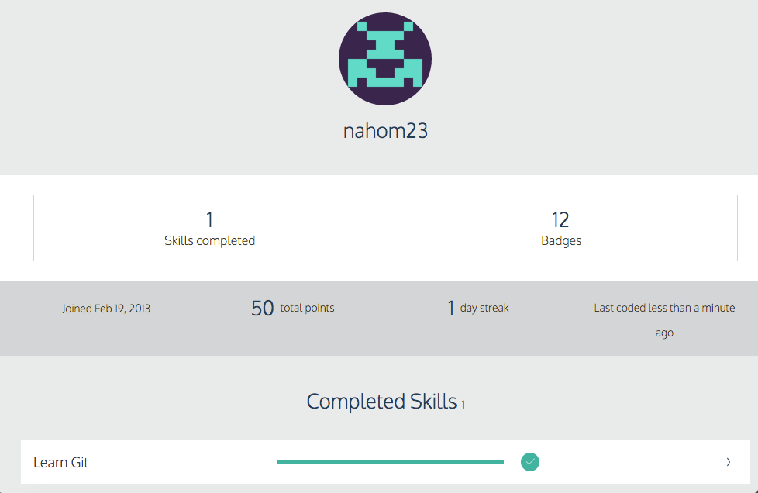

Learning GitHub commands through Code Academy was very encouraging versus my first stint I had with GitHub in Web Development course. My understanding from this mini-tutorial is that Git-hub comes off as code centric social network for developer community. This is where developers store codes (public/private) to enhance code collaboration to share code in work setting or among group project for school. Why I think that makes it powerful is that it offers a distribution channel and discovery for open source libraries.

It offers a log to record of all committed project in this “virtual database”. It gives you the freedom to branch off from a particular position or trace back and start again. This way, you wont forget the ideas you had in the past or helps you promote a new route to a new solution. Also, if you choose to, it allows you to merge the new branch with the master. Thus, Git helps those people who need to coordinate their work to ensure everything works in tandem.

**Task #5**

Analyzing and understanding legacy code such as Fortran77 can be quiet challenging. Not only being exposed to new command of code but requires analyzing the methodology the programmer used when building this project. Throughout the program, I came across ambiguity and minor misunderstandings. One of which were on how the condition on Fortran 77 were executed. I assumed I understood it at first but I found my understanding contradicted what the comment expected the result to be.

I didn’t make many commits on GitHub with this project. The GitHub desktop was preventing me from submitting and accessing the project in the already existing repository. I was hesitant with operating the Github desktop, fearing I would get stuck and kill time. However, I spent time understanding the unique issue I was coming across with the Desktop as well as dedicating time working with this program putting roughly 45 minutes a day on editing and attempting to reengineer different approach without taking it out of it’s character.

What I learned from working on this project is that it requires a heavy patience. Patience to understand what the project is doing and you are interpreting it the best of you ability. This will enhance the ability to reengineer a lot smoother. Also, GitHub still requires patience. While it’s a lot easier to manage verses command line, it does have its unique claws that need to be addressed. For me, every time I try to submit my work in already existing repository, after I locate the file in “open in finder”, it activates my code in a different IDE (Sublime 3) and I wasn’t sure what I was supposed to do from there. So figuring that out was fun.